Hệ thống CRM cho doanh nghiệp bất động sản Tuan321

*:*

Lê Minh Tuấn, Vũ Đức Hòa

Nguyễn Đình Chiến, Đinh Ngọc Khánh, Nguyễn Văn Sơn,

Tháng 12/2020

# 

# Giới thiệu

Công ty bất động sản Tuan321 thực hiện các hoạt động kinh doanh nhà ở, văn phòng:

* Xây dựng, mua bán, chuyển nhượng
* Cho thuê căn hộ, nhà ở, văn phòng.
* Thực hiện dịch vụ môi giới bất động sản.
* Vận hành các sản phẩm bất động sản.

Công ty quy mô 80 nhân viên, 1000 cộng tác viên bán hàng (sale). Để tăng tính cạnh tranh trên thị trường bất động sản bằng cách tìm hiểu thêm về nhu cầu và hành vi của khách hàng từ đó tạo ra các chiến dịch marketing, sale đúng đối tượng khách hàng, công ty Tuan321 mong muốn triển khai hệ thống CRM .

Hệ thống CRM mới sẽ giải quyết các vấn đề chính sau:

* **Kết nối tiếp cận khách hàng:** Tìm kiếm, phân loại khách hàng, tiếp thị tự động đến khách hàng.
* **Quản lí hoạt động mua hàng:** Quản lí thông tin các sản phẩm, dịch vụ, bảng giá, đơn hàng.
* **Chăm sóc khách hàng:** Lưu trữ các câu hỏi thường gặp, quản lí các khiếu nại, vụ việc phát sinh
* **Lưu trữ thông tin:** Thông tin bao gồm lịch sử thanh toán, lịch sử giao dịch, thông tin cá nhân của khách hàng , t hông tin bất động sản, trạng thái giao dịch, lịch làm việc, doanh số nhân viên, cộng tác viên phải được lưu trữ và biểu diễn một cách hợp lí.
* **Hoạch định chiến lược kinh doanh, tiếp thị:** Đưa ra các báo cáo về doanh thu so sánh trên từng khu vực, báo cáo tài chính từ đó đưa ra các chiến lược kinh doanh hợp lí.

# Pha khởi đầu

To guide future changes in their business and information technology, ArchiSurance has decided to develop an enterprise architecture based on TOGAF 9.1 and ArchiMate 2.0 with minimal tailoring.

As part of the Preliminary Phase, the main stakeholders in the architecture engagement and their concerns (modeled as internal drivers in ArchiMate) are identified. TOGAF defines a Stakeholder Map matrix to represent this. In ArchiMate, this can be expressed using the Stakeholder viewpoint:

The stakeholder viewpoint allows the analyst to model the stakeholders, their concerns, and the assessments (in terms of strengths, weaknesses, opportunities, and threats) of these concerns. Also, the links to the initial (high-level) goals that address these concerns and assessments may be described.

Figure 3 shows a part of such a diagram, identifying two stakeholders (the ArchiSurance board of directors and its current and potential customers) and their concerns, modeled as drivers. Customer satisfaction is a shared concern of both stakeholders. Stakeholder satisfaction can be refined into more detailed concerns; e.g., profit.

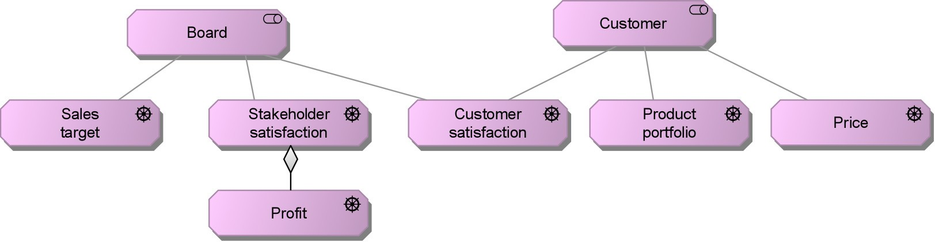

Figure 3: Fragment of a Stakeholder View

Drivers motivate the development of specific business goals, as shown below for profit. Goals such as cost reduction can be partitioned into the reduction of maintenance costs and the reduction of personnel costs.

ArchiMate defines a principle as either a normative property of all systems in a given context, or a normative property of the way in which they are realized. Note that “systems” here include, for example, organizations and organization units, not only IT systems. Principles, therefore, help realize business goals. TOGAF defines a principle as a qualitative statement of intent that should be met by an architecture. A principle must have a supporting rationale and a measure of importance.

The ArchiMate Principles viewpoint, an example of which is shown in Figure 5, depicts principles, their dependencies, and the goals they realize in a graphical way:

The Principles viewpoint allows the analyst or designer to model the principles that are relevant to the design problem at hand, including the goals that motivate these principles. In addition, relationships between principles, and their goals, can be modeled. For example, principles may influence each other positively or negatively.

TOGAF defines a Principles catalog to provide an overview of principles.

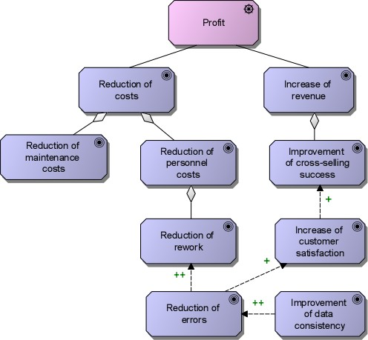

Figure 4: Business Goals Associated with the Driver Profit

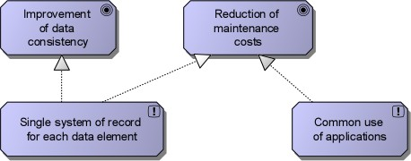

Figure 5: Principles View

# Pha B: Kiến trúc nghiệp vụ

After the merger, ArchiSurance set up a shared front-office as a multi-channel contact center for sales and customer service, with a primary contact center at the pre-merger headquarters of Home & Away. There are still three separate back-offices that handle the insurance products of the three original companies. A Shared Service Center (SSC) has been established for document processing at the pre-merger headquarters of PRO- FIT. The center administers the central document repository as well as all automated document workflows. In addition, it performs all scanning, printing, and archiving for legally binding documents as they enter or leave ArchiSurance. To ensure business continuity and handle periods of peak activity, the SSC also hosts trained personnel and equipment to perform the functions of the front-office, which is similarly prepared to reciprocate.

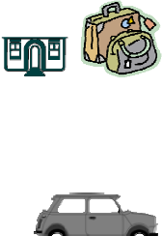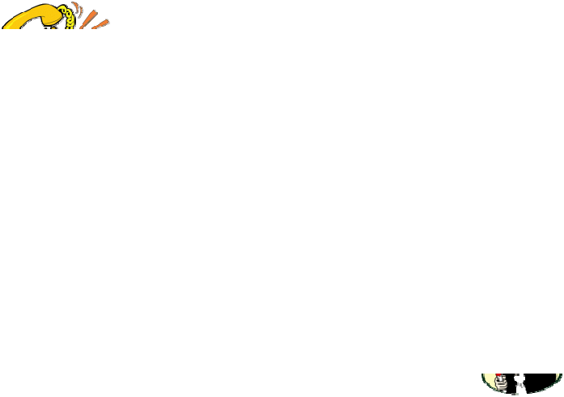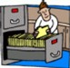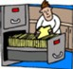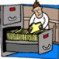

Home & Away headquarters

Homeowner’s & Travel back office

PRO‐FIT

headquarters

Auto back office

Front office

Legal Expense back office

Shared Service Center

Figure 6: Global Organizational Structure of ArchiSurance

In Phase B (Business Architecture) of the TOGAF ADM, ArchiMate can express and relate ArchiSurance organizational structure, products, services, functions, processes, and information. The business architecture provides context for the data, application, and technology architectures.

## Organization Structure

For describing the organization structure, ArchiMate defines the Organization viewpoint:

The Organization viewpoint focuses on the (internal) organization of a company, a department, a network of companies, or of another organizational entity. It is possible to present models in this viewpoint as nested block diagrams, but also in a more traditional way, such as organizational charts. The Organization viewpoint is very useful in identifying competencies, authority, and responsibilities in an organization.

The TOGAF counterpart of this viewpoint is the Organization Decomposition diagram.

The organization structure is often represented as a tree, as shown in Figure 7, although the organizational decomposition approach used by both ArchiMate and TOGAF has far more options than a simple tree-style organizational chart. This view shows the high-level organization structure of ArchiSurance, with its main

locations and departments. Alternatively, a nested diagram can depict the subdivision of the organization into locations and departments.

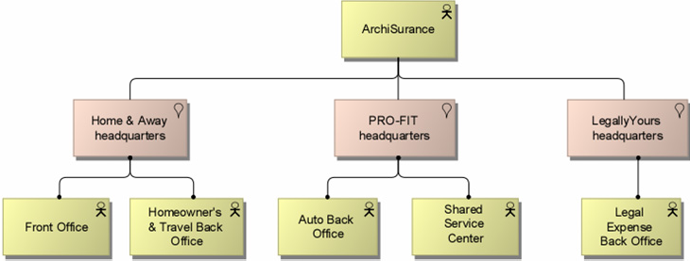

Figure 7: Organization View

## Business Functions

An ArchiMate business function groups behavior based on a chosen set of criteria, typically required business resources and/or competences.

The main business functions that ArchiSurance distinguishes are:

* Marketing, which studies, plans, promotes, and manages products and market segments, and works with Actuarial to design products
* Actuarial, which determines product prices and reserve levels, works with marketing to design new products, and analyzes enterprise risk
* Customer Relations, which includes the interactions between ArchiSurance and its customers; it handles customer questions, captures incoming claims, and conducts direct marketing campaigns
* Underwriting, which sets prices for individual policies and generates insurance proposals and policies
* Claims, which formulates and executes ArchiSurance’s response to each claim against one of its policies
* Finance, which includes regular premium collection, according to the insurance policies with customers as produced by Contracting, and handles the payment of insurance claims
* Document Processing, which supports other functions through document scanning, printing, and archiving
* Investment Management, which manages financial and real estate assets for maximum returns within corporate and regulatory liquidity and risk constraints

Some of these business functions are replicated in the three divisional back-offices of ArchiSurance.

To model business functions and their relationships, ArchiMate defines the Business Function viewpoint:

The Business Function viewpoint shows the main business functions of an organization and their relationships in terms of the flows of information, value, or goods between them.

The TOGAF counterpart of this viewpoint is the Functional Decomposition diagram.

Figure 8 shows the main business functions of ArchiSurance, as well as the most important information flows between the functions and external roles. It also shows the replication of business functions in the back- offices of the different divisions.

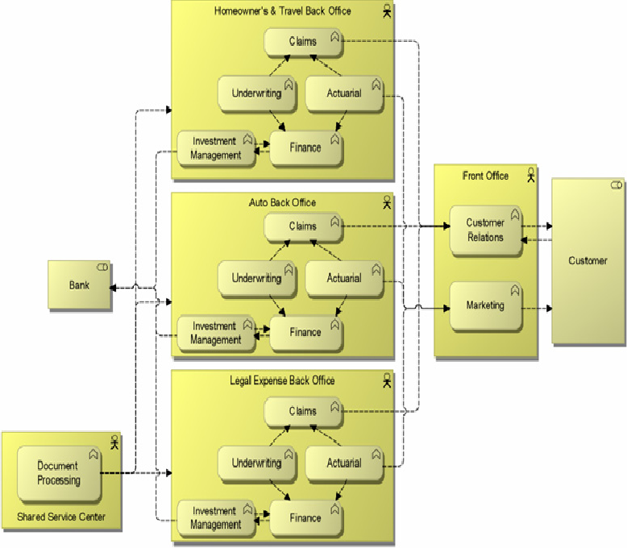

Figure 8: Business Function View

## Business Processes

An ArchiMate business process groups behavior based on an ordering of activities. It produces a defined set of products or services. A process architecture shows the most important business processes and their relationships, and possibly the main steps within each of the processes. It usually does not show all the details of a process flow, which is the purpose of business process design languages. ArchiMate defines a Business Process viewpoint:

The Business Process viewpoint is used to show the high-level structure and composition of one or more business processes.

The TOGAF counterpart of this viewpoint is the Process Flow diagram.

Figure 9 shows the two central business processes of ArchiSurance, with their high-level sub-processes: Close contract, which is performed when selling a new insurance product, and Handle claim, which is performed when a damage claim has been received. While the details of these processes may differ for the different types of insurance product, the main steps are the same.

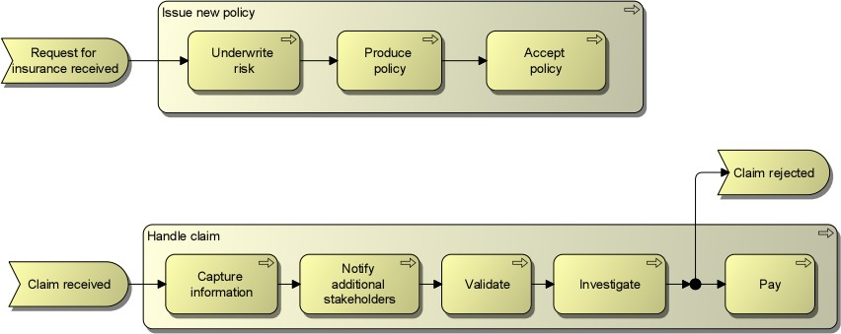

Figure 9: Business Process View

# Pha C: Kiến trúc dữ liệu

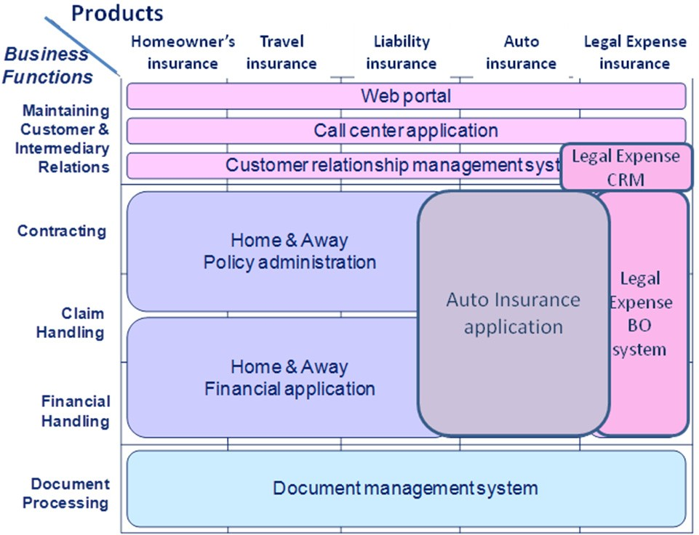Since the merger, the three divisions have adopted a common web portal, contact center software suite, and document management system. Also, the company has selected a strategic CRM solution and implemented it for both Home & Away and PRO-FIT. However, due to management’s focus on minimizing post-merger risks while continually improving the day-to-day performance of each division, core business application rationalization has not begun. Now that ArchiSurance has met post-merger performance expectations, investors expect substantial IT cost savings through the adoption of a common set of product and customer- focused applications. Therefore, a number of challenges remain. Home & Away still uses its pre-merger policy administration and financial application packages, while PRO-FIT and Legally Yours still use their own pre-merger custom monolithic applications.

Figure 10: Application Landscape

## Application Co-Operation

ArchiMate defines an Application Co-operation viewpoint to show an overview of the application landscape and the dependencies between the applications:

The Application Co-operation viewpoint describes the relationships between applications components in terms of the information flows between them, or in terms of the services they offer and use. This viewpoint is typically used to create an overview of the application landscape of an organization. This viewpoint is also used to express the (internal) co-operation or orchestration of services that together support the execution of a business process.

The TOGAF counterpart of this viewpoint is the Application Communication diagram.

Figure 11 shows the main applications of ArchiSurance, as well as the main data flows between the applications.

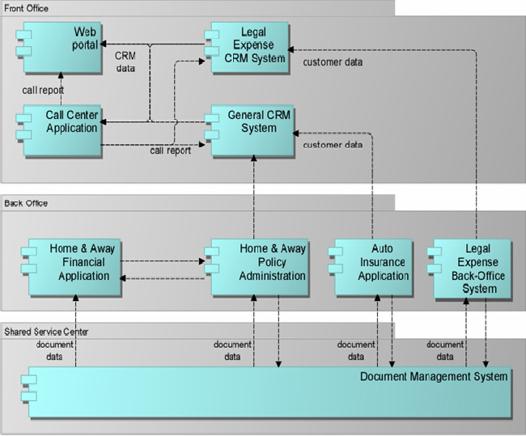

Figure 11: Application Co-Operation View

## Business-Application Alignment

TOGAF does not define diagrams for business-application alignment. However, it does specify matrix-based viewpoints to show the links between the business and the application architecture; e.g., an Application/Organization matrix and an Application/Function matrix.

The relationships between application components can also be modeled graphically. ArchiMate defines the Application Usage viewpoint:

The Application Usage viewpoint describes how applications are used to support one or more business processes, and how they are used by other applications. It can be used in designing an application by identifying the services needed by business processes and other applications, or in designing business processes by describing the services that are available. Furthermore, since it identifies the dependencies of business processes upon applications, it may be useful to operational managers responsible for these processes.

The Application Service concept plays a central role in this viewpoint. Figure 12 shows a subset of the services offered by the applications used by the Home & Away division of ArchiSurance, and which of the sub-processes of the claim handling process make use of which of these services.

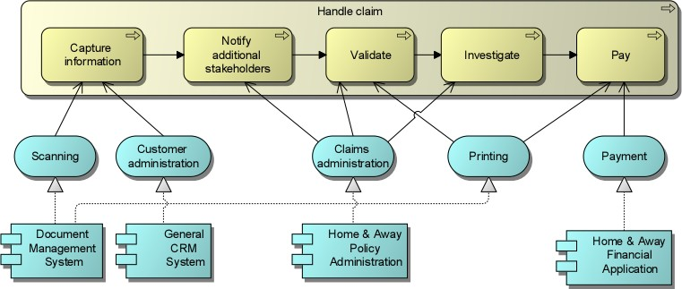

Figure 12: Application Usage View

# Phase C: Baseline Information Systems Architectures (Data)

The ArchiSurance data architecture describes the major relationships between its conceptual business objects and its logical data objects. ArchiMate defines the Information Structure viewpoint for this purpose:

The Information Structure viewpoint is comparable to the traditional information models created in the development of almost any information system. It shows the structure of the information used in the enterprise or in a specific business process or application, in terms of data types or (object-oriented) class structures.

One of the data viewpoints that TOGAF defines is the Logical Data diagram.

Figure 13 shows a subset of the business objects that ArchiSurance defines. Part of the customer information is an insurance file, which is composed of insurance requests, insurance policies, and damage claims. A number of specializations of the insurance policy object are defined, one for each type of insurance that ArchiSurance sells.

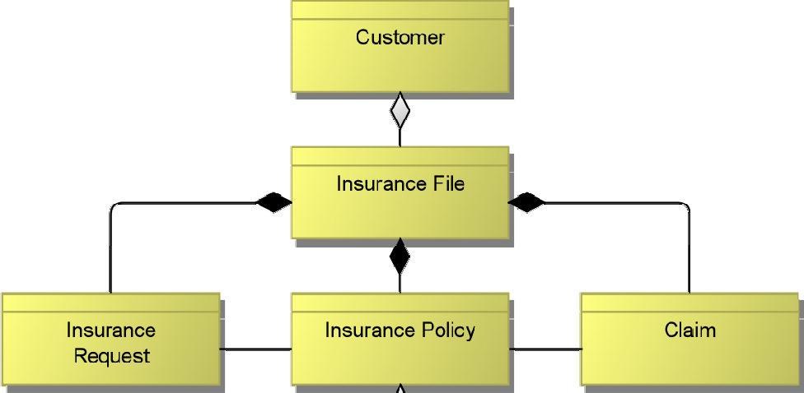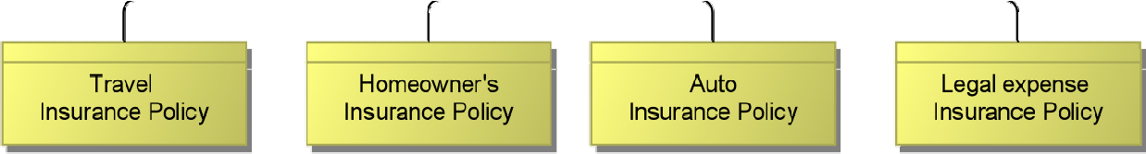

Figure 13: Information Structure View

Another data viewpoint that TOGAF defines is the Data Dissemination diagram:

The purpose of the Data Dissemination diagram is to show the relationship between data entity, business service, and application components. The diagram shows how the logical entities are to be physically realized by application components. This allows effective sizing to be carried out and the IT footprint to be refined.

Moreover, by assigning business value to data, an indication of the business criticality of application components can be gained.

Figure 14 shows a Data Dissemination diagram for one ArchiSurance application.

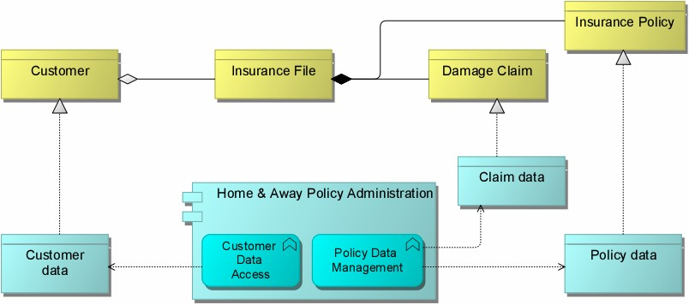

Figure 14: Data Dissemination Diagram

# Phase D: Baseline Technology Architecture

Figure 15 sketches the technical infrastructure landscape of ArchiSurance. In the front-office, located at the Home & Away headquarters, there is a general-purpose server and one dedicated to web hosting. The Shared Service Center (SSC), located at the PRO-FIT headquarters, has its own server for the document management system. Each of the three back-offices has a server for its applications.

A Local Area Network (LAN) connects servers and personal computers at each of the three ArchiSurance locations, which are in turn connected by a corporate Wide Area Network (WAN).

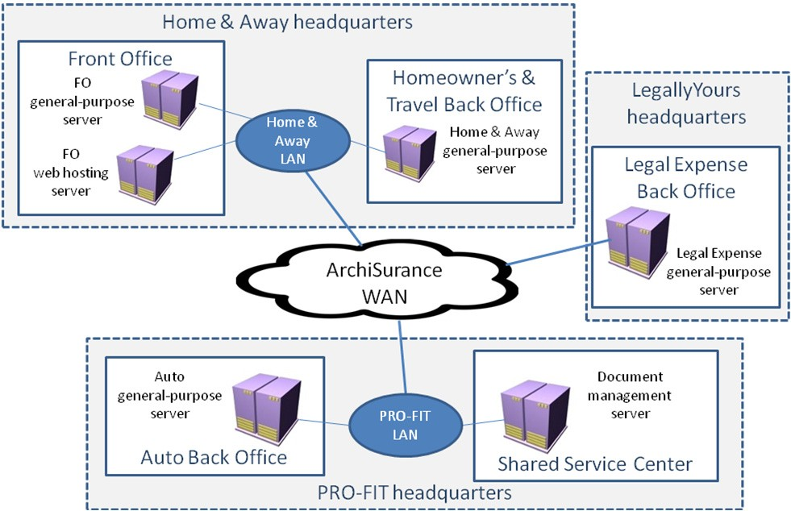

Figure 15: Infrastructure Landscape

For an overview of the infrastructure landscape, ArchiMate defines the Infrastructure viewpoint:

The Infrastructure viewpoint contains the software and hardware infrastructure elements supporting the Application Layer, such as physical devices, networks, or system software (e.g., operating systems, databases, and middleware).

The TOGAF counterpart of this viewpoint is the Environments and Locations diagram.

Figure 16 shows the main infrastructure components of ArchiSurance, grouped by location and department. Also the networks that connect the different devices, and the (application) artifacts deployed on the devices, are shown in this view.

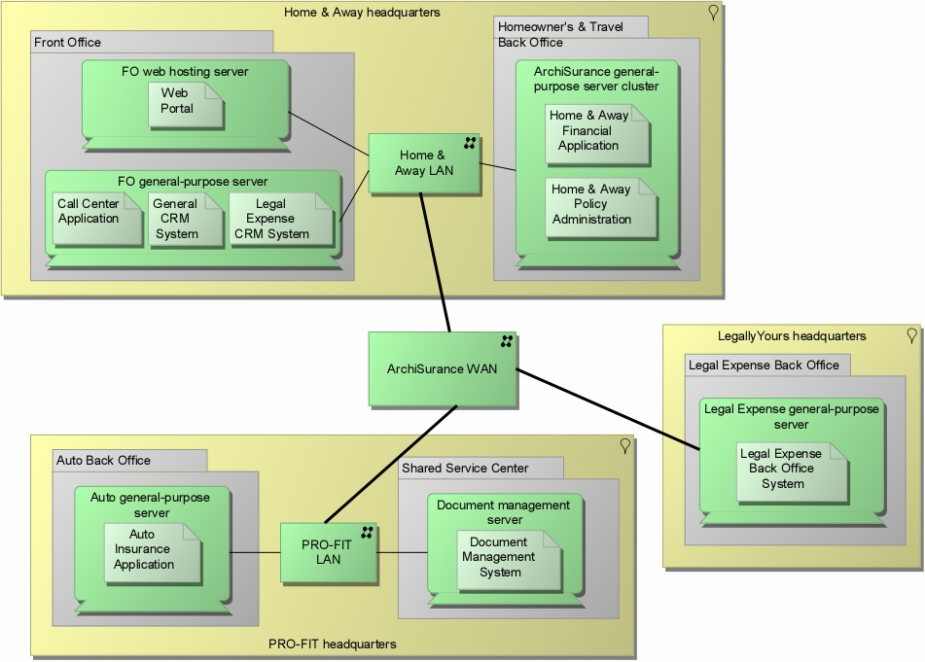

Figure 16: Infrastructure View

# Change Scenarios

## Scenario 1: Application Portfolio Rationalization

The inflexibility of the ArchiSurance application architecture makes it difficult to adapt to changes in business conditions. Partly as a result of the merger, the application landscape has become scattered, resulting in data redundancy and functional overlap, as well as point-to-point application integration using a variety of data formats and methods. These problems cause internal instabilities, increased application maintenance costs, and obstacles to sharing information across the company and with partners. Consequently, the IT department has a sizable backlog of work requests. ArchiSurance top management is very concerned about the backlog, particularly an unmet need to share information automatically with high-volume contracted sales partners and influential insurance consultants.

This scenario rationalizes the ArchiSurance application portfolio by:

* Migrating to an integrated back-office suite for functions such as policy administration and financial transactions. The suite will consist of:
  + *AUTO-U*, an automated underwriting system that generates proposals and policies
  + *P-ADMIN*, a packaged policy administration system that integrates with the automated underwriting system to issue, modify, and renew policies; this system also handles customer accounting and billing
  + *VERSA-CLAIM*, a packaged claims system with screens and workflow that can be configured to support ArchiSurance’s three lines of business
  + *P-CONFIG*, a product configurator management used to define all insurance products, and expose these definitions to AUTO-U, P-ADMIN, and VERSA-CLAIM through web services
  + *BRIMS,* a business rule management system (BRMS) consisting of a rules repository, a processing engine, a rule development environment, and an authoring tool for rule management user interfaces. The business rule engine exposes rule execution capabilities to AUTO-U, P- ADMIN, VERSA-CLAIM, and P-CONFIG through web services.
* Completing the migration to the strategic CRM system

The ArchiSurance lead investors and CEO support these initiatives on the condition that all changes are invisible to ArchiSurance customers and partners. The insurer’s products and services must not be affected, and all customer and partner interactions must proceed uninterrupted and unchanged.

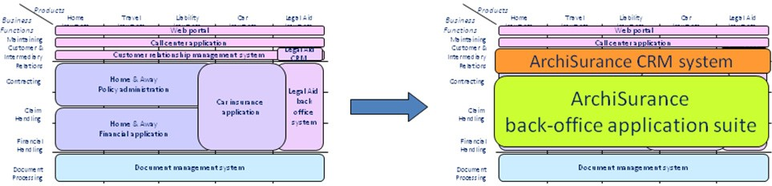

Figure 17: Application Portfolio Rationalization

As part of this effort, the technical infrastructure will also be simplified. The separate back-office servers will be replaced by a shared server cluster located in the data center at Home & Away headquarters. However, to ensure business continuity, there will also be a back-up server cluster located in the data center at PRO-FIT headquarters.

***Phase A: Architecture Vision***

Phase A of the TOGAF ADM establishes an architecture effort and initiates an iteration of the architecture development cycle by setting its scope, constraints, and goals. This phase also validates the business context and develops a Statement of Architecture Work.

The business context consists of the key business requirements based upon the main business goals and architecture principles. Some relevant business goals and principles for the current scenario are shown in Figure 18.

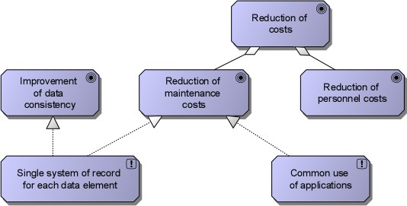

Figure 18: Business Goals and Principles

Goals and principles are the basis for concrete requirements, as shown in an ArchiMate Goal Refinement viewpoint:

The Goal Refinement viewpoint allows a designer to model the refinement of (high-level) goals into more concrete goals, and the refinement of concrete goals into requirements or constraints that describe the properties that are needed to realize the goals. The refinement of goals into sub-goals is modeled using the aggregation relationship. The refinement of goals into requirements is modeled using the realization relationship.

Figure 19 shows an example of such a view for the current change scenario.

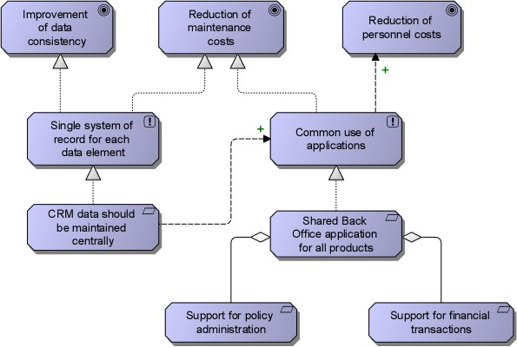

Figure 19: Goal Refinement View

An important element of the architecture vision is a high-level representation of the baseline and target architectures, to explain the added value of the architecture effort to stakeholders. For this purpose, ArchiMate defines the Introductory viewpoint:

The Introductory viewpoint forms a subset of the full ArchiMate language using a simplified notation. It is typically used at the start of a design trajectory, when not everything needs to be detailed yet, or to explain the essence of an architecture model to non-architects that require a simpler, more intuitive notation. Another use of this basic, less formal viewpoint is that it tries to avoid the impression that the architectural design is already fixed, an idea that may easily arise when using a more formal, highly structured, or detailed visualization.

The TOGAF counterpart of this viewpoint is the Solution Concept diagram.

The example below highlights the most important changes that are needed in the current change scenario:

* In the Front-Office, the separate CRM system for Legal Expense will disappear.
* In the Back-Office, the separate back-office applications will be replaced with a single back-office suite. The three separate general-purpose back-office servers will be replaced by a shared server cluster and a back-up server cluster.

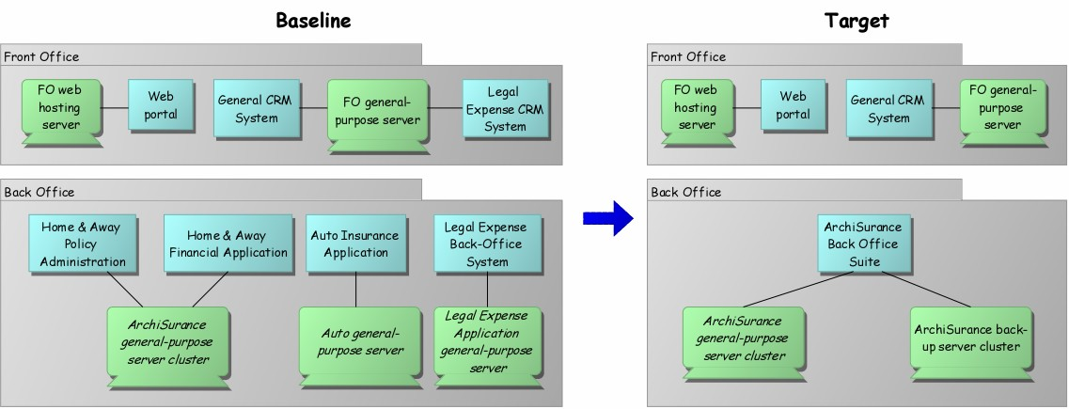

Figure 20: Introductory View

***Phase B: Target Business Architecture and Gap Analysis***

In this scenario, the business architecture remains unchanged. However, in the business architecture, we also show how the target architecture realizes the key business requirements. For this purpose, TOGAF specifies a Business Footprint diagram. In ArchiMate, this can be expressed using the Requirements Realization viewpoint, defined as follows:

The Requirements Realization viewpoint allows the designer to model the realization of requirements by the core elements, such as business actors, business services, business processes, application services, application components, etc. Typically, the requirements result from the goal refinement viewpoint.

The example below shows how the business requirements established in the architecture vision phase are realized by elements in the architecture.

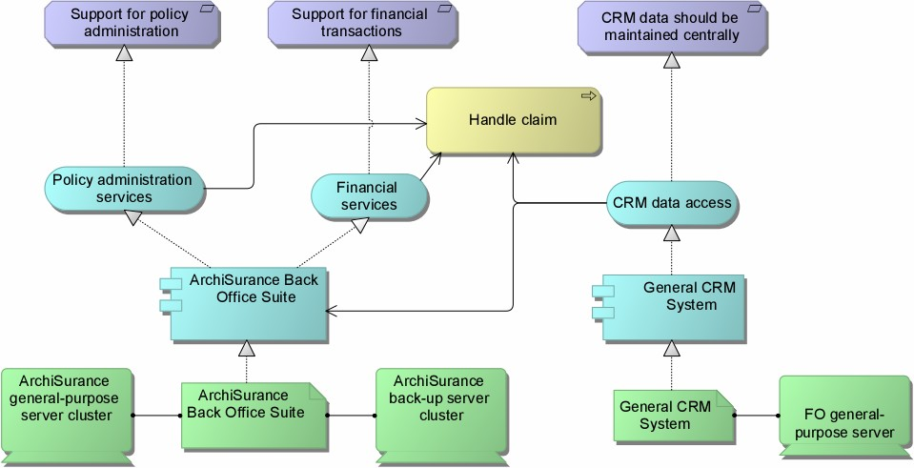

Figure 21: Requirements Realization View

***Phase C: Target Application Architecture and Gap Analysis***

The Application Communication diagram below shows the proposed target situation for the application landscape.

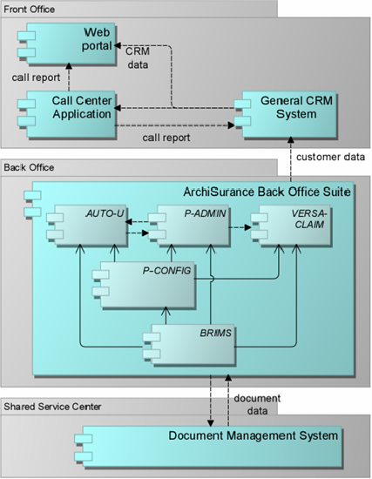

Figure 22: Target Application Architecture: Application Co-Operation View

The results of a global gap analysis for the application architecture are visualized below. Several application components that exist in the baseline architecture are no longer present in the target architecture: the separate back-office applications and the separate Legal Expense insurance CRM system. The CRM functionality for Legal Expense insurance customers is taken over by the general CRM system; therefore, this does not require new components (although it may be necessary to adapt or reconfigure the existing general CRM system, this is not shown in the gap analysis). In addition, a completely new back-office application suite is introduced.

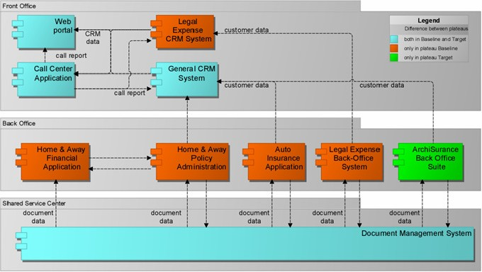

Figure 23: Application Architecture: Gap Analysis

***Phase D: Target Technology Architecture and Gap Analysis***

The Infrastructure view below shows the proposed target situation for the technical infrastructure landscape.

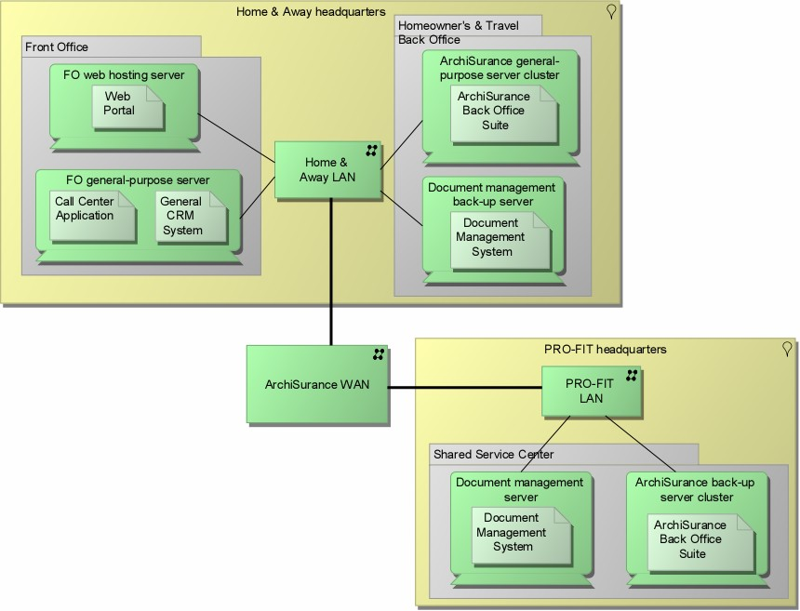

Figure 24: Target Technology Architecture: Infrastructure View

Figure 25 visualizes the results of a global gap analysis for the technology architecture. The separate general- purpose back-office servers are slated for removal. The original server cluster of Home & Away is to become the central ArchiSurance back-office service cluster, and an additional back-up server cluster is to be placed in the SSC at PRO-FIT headquarters. There is also a back-up document management server to be placed in the Home & Away back-office. The new back-office suite and the document management system are to be replicated on their respective main servers and back-up servers.

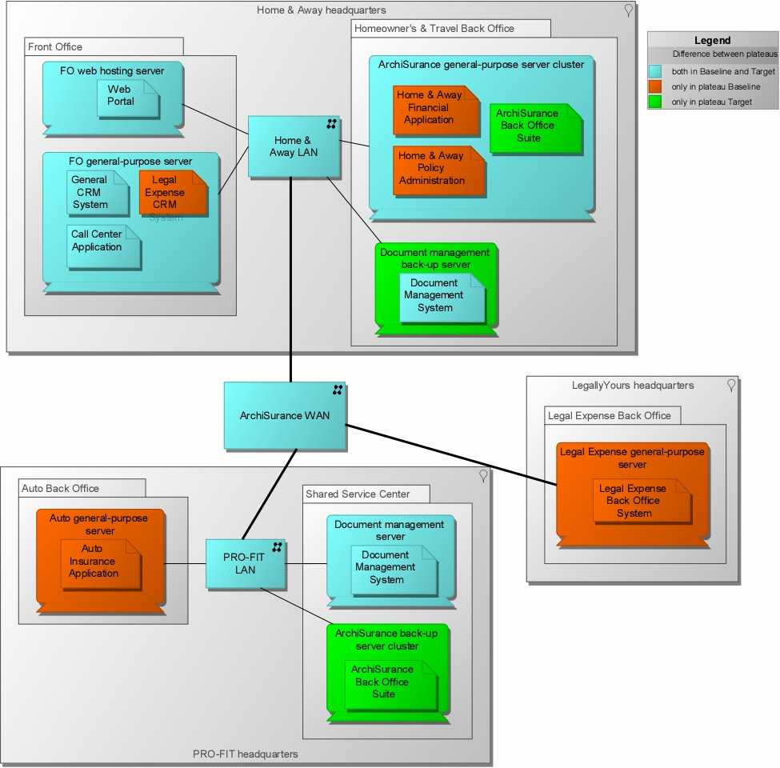

Figure 25: Technology Architecture: Gap Analysis

***Implementation and Migration Planning***

TOGAF 9 introduces for Phases E and F the *transition architecture*, representing a possible intermediate situation (“plateau”) between the baseline architecture and the target architecture.

In ArchiMate, the baseline, target, and transition architectures, as well as their relationships, are shown using the Migration viewpoint:

The Migration viewpoint entails models and concepts that can be used for specifying the transition from an existing architecture to a desired architecture.

Figure 26 shows an example for the current scenario. The IT department of ArchiSurance does not have sufficient resources to carry out the integration of the back-office systems and the integration of the CRM systems in parallel. One transition architecture therefore replaces two CRM systems with one, but has separate back-office systems. Another has a single back-office suite but two CRM applications.

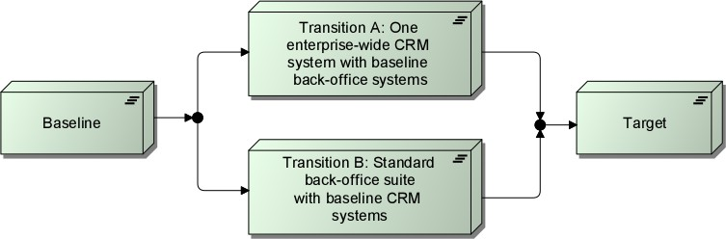

Figure 26: Migration View

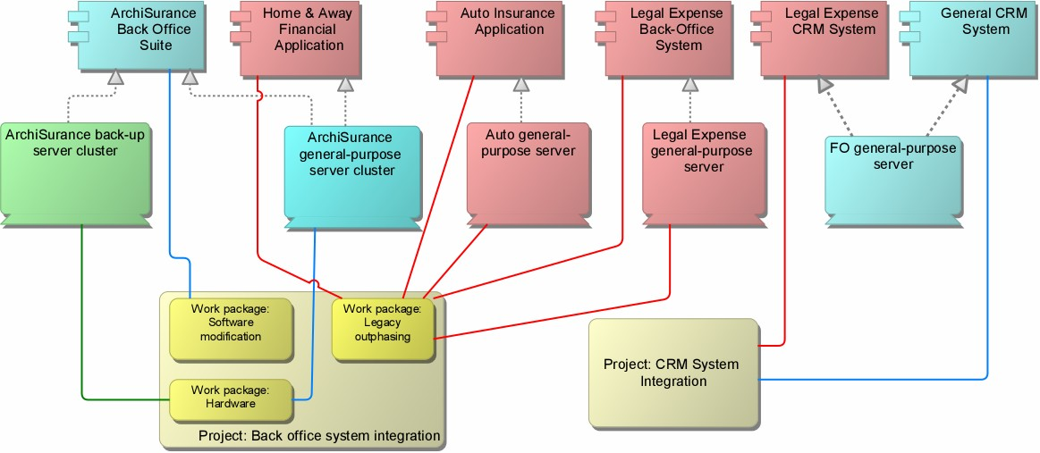Transition architectures enable the planning of implementation projects such as CRM integration and back- office application integration. The sequence of these projects depends on which of the transition architectures is selected. This can be is shown in a TOGAF Project Context diagram (Figure 27):

A Project Context diagram shows the scope of a work package to be implemented as part of a broader transformation roadmap. The Project Context diagram links a work package to the organizations, functions, services, processes, applications, data, and technology that will be added, removed, or impacted by the project.

Figure 27: TOGAF Project Context Diagram, expressed in ArchiMate

## Scenario 2: Online Portfolio Management

In this scenario, that assumes the target state of Scenario 1 as the new baseline, customers gain direct access to their insurance portfolios through the web. This reduces the number of customer interactions with the front-office by enabling customers to:

* Securely purchase, renew, or modify their homeowner’s, travel, auto, or legal expense insurance online consistent with the rules that ArchiSurance uses to conduct its business
* Receive help with their online transactions by:
  + Searching a knowledge base for answers
  + Initiating a chat session with a Customer Service Representative (CSR)
  + Using a web form to compose and submit an email that will be answered by a CSR
  + Using a web form to request a phone call from a CSR
* Access information and special offers from ArchiSurance partners that are tailored to their needs, such as banking and financial planning services, investments, credit cards, and other types of insurance

For this scenario, there are no models available yet. The Open Group encourages its members to contribute to future versions of this Case Study. Contributors may extend or add detail to the two scenarios presented here, or they may create new scenarios. In order to foster a coherent body of work, however, the baseline architectures for new change scenarios should be either the baselines or targets of the change scenarios presented here.

# References

1. TOGAF® Version 9.1, The Open Group, published by The Open Group, 2011 ([www.opengroup.org/togaf).](http://www.opengroup.org/togaf))
2. ArchiMate® 2.0 Specification, The Open Group, due January 2012.
3. Doest, H., Iacob, M.-E., Lankhorst, M.M. (Ed.) & van Leeuwen, D.: Viewpoints Functionality and Examples, ArchiMate Deliverable D3.4.1a v2, TI/RS/2003/091, Telematica Instituut, Enschede, The Netherlands, 2004.
4. van den Berg, H., Moelaert, F.: PRO-FIT Autoschade Open Case Testbed, Testbed Deliverable WP3/N004/V001, TRC, Enschede, The Netherlands, 1997.

# About the Authors

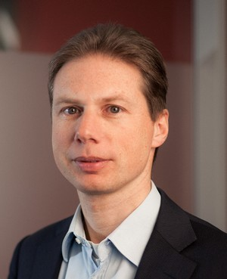



**Henk Jonkers** is a Senior Research Consultant at BiZZdesign. In this capacity, he is involved in the company’s new developments in the area of enterprise architecture and enterprise engineering. He also participates in multi-party research projects, contributes to training courses, and performs consultancy assignments. Previously, he worked as a Member of Scientific Staff at Telematica Instituut (currently Novay), where he was involved in various applied research projects in the areas of business process modeling and analysis, enterprise architecture, service-oriented architecture, and model-driven development. Henk was one of the main developers of ArchiMate and an author of the ArchiMate 1.0 and 2.0 Specifications, and is actively involved in the activities of the ArchiMate Forum of The Open Group.

**Iver Band** chairs the Insurance Industry Reference Models Working Group of The Open Group ArchiMate Forum and serves as an enterprise solutions architect at Standard Insurance Company (SIC) in Portland, Oregon. Iver chose TOGAF and ArchiMate for his IT organization, and applies these standards enthusiastically to his daily responsibilities. Prior to his current role, Iver was the SIC enterprise infrastructure architect, where he developed data center, disaster recovery, and server platform strategies that his employer is currently implementing. Prior to SIC, he spent over 16 years at Hewlett-Packard in a variety of technical and management roles, culminating in five years as the security and infrastructure architect responsible for global partner connectivity. He also served as the second Visiting Technologist at HP Labs, where he contributed to several research projects and led the development of a patented method for network security management. Iver has been a Certified Information Systems Security Professional (CISSP) since 2005.

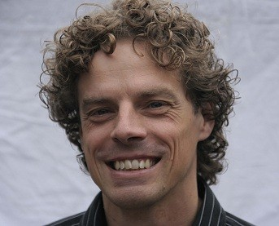**Dick Quartel** is a Senior Research Consultant at BiZZdesign. In this role he contributes to the development and improvement of BiZZdesign's products and services, is involved in research projects, supervises MSc students and interns, and performs consultancy assignments. In addition, he is an author of many scientific and professional publications, and an author of the ArchiMate 2.0 Specification.

Previously, he worked as a Senior Researcher at Novay (formerly Telematica Instituut), where he acted as researcher and project manager and contributed to the definition and acquisition of research projects, and as an Assistant Professor at the University of Twente in the areas of distributed systems design, protocol design and implementation, and middleware systems.

# Acknowledgements

The authors wish to thank the following individuals for their assistance with this Case Study:

* + Karen Lindokken, Standard Insurance Company
  + R. Allampalli, Cognizant Technology Solutions

# About The Open Group

The Open Group is a global consortium that enables the achievement of business objectives through IT standards. With more than 400 member organizations, The Open Group has a diverse membership that spans all sectors of the IT community – customers, systems and solutions suppliers, tool vendors, integrators, and consultants, as well as academics and researchers – to:

* + Capture, understand, and address current and emerging requirements, and establish policies and share best practices
  + Facilitate interoperability, develop consensus, and evolve and integrate specifications and open source technologies
  + Offer a comprehensive set of services to enhance the operational efficiency of consortia
  + Operate the industry’s premier certification service

Further information on The Open Group is available at [www.opengroup.org.](http://www.opengroup.org/)